**EMBEDDED SYSTEM AND DESIGN**

**EXPERIMENT**

**Desk Stand Up Reminder**

Name: NAVARRO, ROD GERYK C.

Course/Section: CPE160P-4/A1

Group No.: N/A

Date of Performance: 10/03/2024

Date of Submission: 10/04/2024

CRYREL O. MANLISES, PH.D.

Instructor

**OBJECTIVES**

* To be able to demonstrate and create a stand-up reminder using Arduino R3.
* To be able to apply embedded system in reminding the user when to stand-up if the user sits for a long period of time using LCD, and 4-bit seven segment display, as well as the use buttons, ultrasonic sensor and a buzzer.
* To be able to effectively remind the user when the time to stand up especially if the user has the habit of sitting for a long period of time or has a work that allows the user to sit for a long time.
* To be able to use the skills learned and the functionality of at least five of the seven embedded system and design experiments.

**DISCUSSION**

Long periods of sitting are bad for our bodies and health. More and more studies point to the potential health advantages of simply standing, even if you don't move. To achieve the proper balance, sit 20 minutes out of every half hour at work, standing for eight minutes and moving around for at least two minutes (Storrs, 2015). It is recommended to use the 20-8-2 rule which allows a person to sit for about 20 minutes, stand up for 8 mins, and move around for 2 mins. The user can change their time for sitting and standing for this project depending on the preference of the user. The goal of this project is to create a mini desk gadget that will sound an alarm when a person has been sitting for too long. This is a basic Arduino project that uses a 4-bit seven-segment display to show the user-set time, an LCD I2C 1602 to show what needs to be done at the current present moment, LEDs that will serve as an indicator to prepare the user when it's time to stand up, and a buzzer that activates as an alarm when a user sits for an extended period of time. In addition to this, to stop the activation of the alarm an ultrasonic sensor will be used to force the alarm to stop, the user will just hover his/her hand on the top of the sensor in order to stop it. When the time for standing up is finished, the user is free when to start the timer for sitting. The same process when starting the timer for sitting, the user will hover his/her hand on top of the sensor to activate it again.

Any microcontroller may be utilized to complete this Arduino project. However, the Arduino Uno microcontroller will be the one to use in this project to get the desired results. In addition to messages that can encourage the user to get up and move their body, the LCD display will also display messages that can serve as a reminder to accomplish tasks at the appointed times. There is a saying that if the body move the mind grooves. Numerous health advantages of this stand-up reminder encourage people to maintain an active lifestyle while engaging in what they like to do. Furthermore, a 4-bit, seven-segment display will provide a countdown timer so that the user will be aware when it's time to stand up.

**EXPERIMENTS**

**Experiment 01: Symphony of Lights**

The experiment symphony of lights, uses LED patterns similarly in this project where I will use LEDs that will blink as an indication to prepare the user to stand up and start the work/sitting time again.

**Experiment 02: Number System Emulator**

In this project where I will used multiple buttons to set the time of the reminder and to control the time its likely similar to this experiment where multiple buttons are used to convert various number systems.

**Experiment 03: Clock**

The main functionality that this experiment apply to my project is mainly the used of the 4-bit seven segment display. I learned to use this display in the experiment where I created a clock, which I will also apply in this project as a countdown timer so that the user will be aware when it's time to stand up.

**Experiment 04: Kettle**

Similar to this experiment I will also create an alarm system using a buzzer that will activate when it’s time to stand up after sitting for too long. In the experiment, the alarm is triggered by the DH11 sensor, but in this project, it is triggered by the user’s set time.

**Experiment 06: Automatic Trash Can**

The main indicator in this experiment is the use of the ultrasonic sensor that detects if the trash is full and push the trash with the compressor. In my project I also use an ultrasonic sensor to start the work/sitting time again after the standing time. The user will just hover their hands on the top of the sensor to trigger it.

**LIST OF MATERIALS**

1x Arduino kit

1x Arduino R3

5x Switch/buttons w/ resistors

1x LCD

1x 4-digit seven segment display w/ resistors

2x LEDs w/ resistors

1x Ultrasonic sensor

1x Buzzer w/resistor

**BLOCK DIAGRAM**

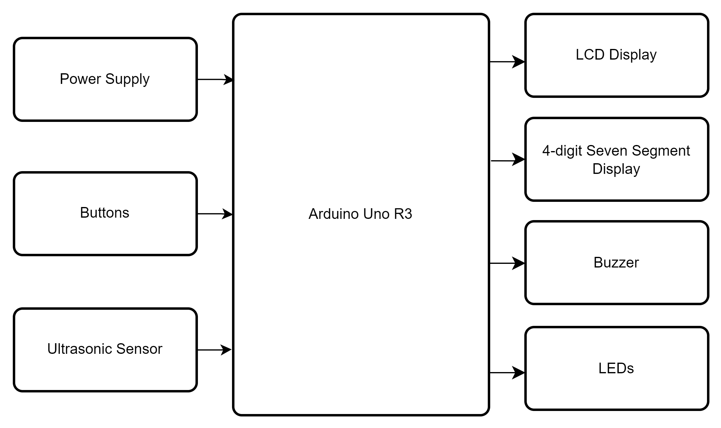

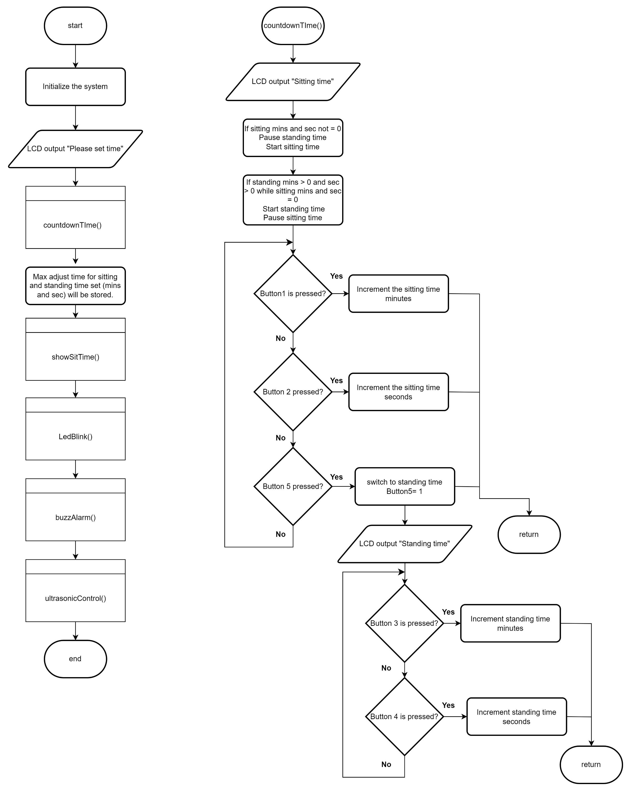**FLOWCHART**

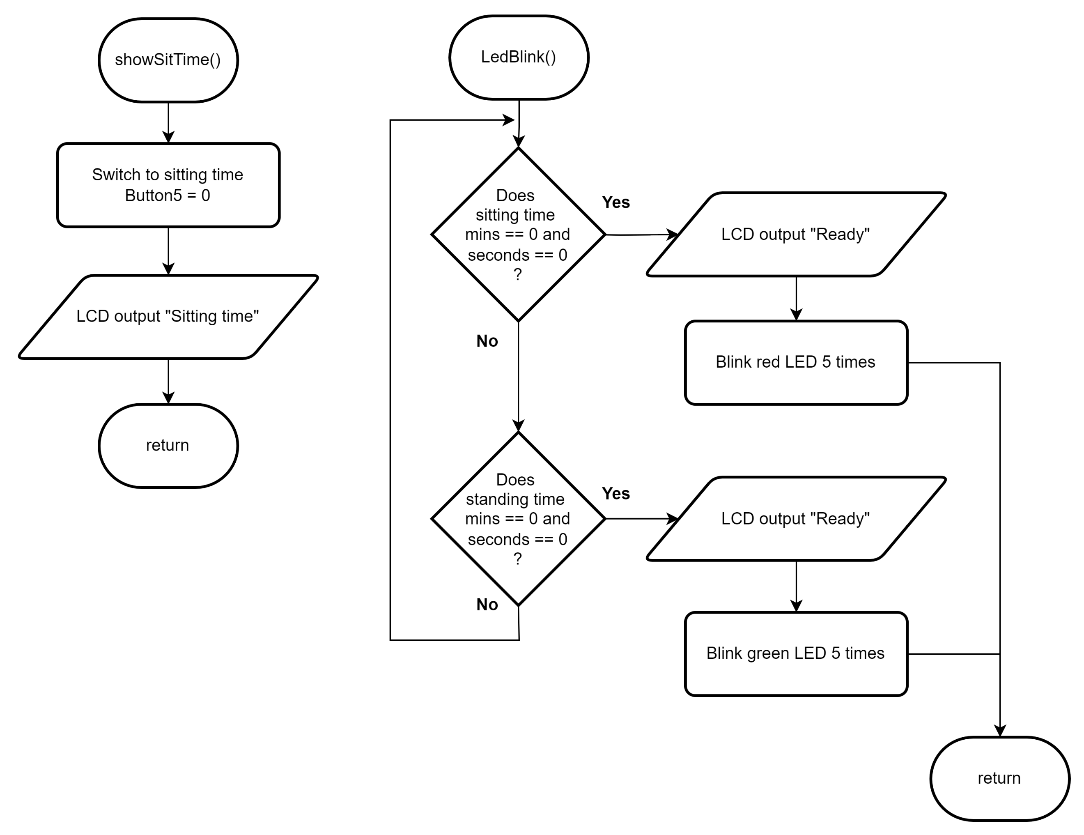

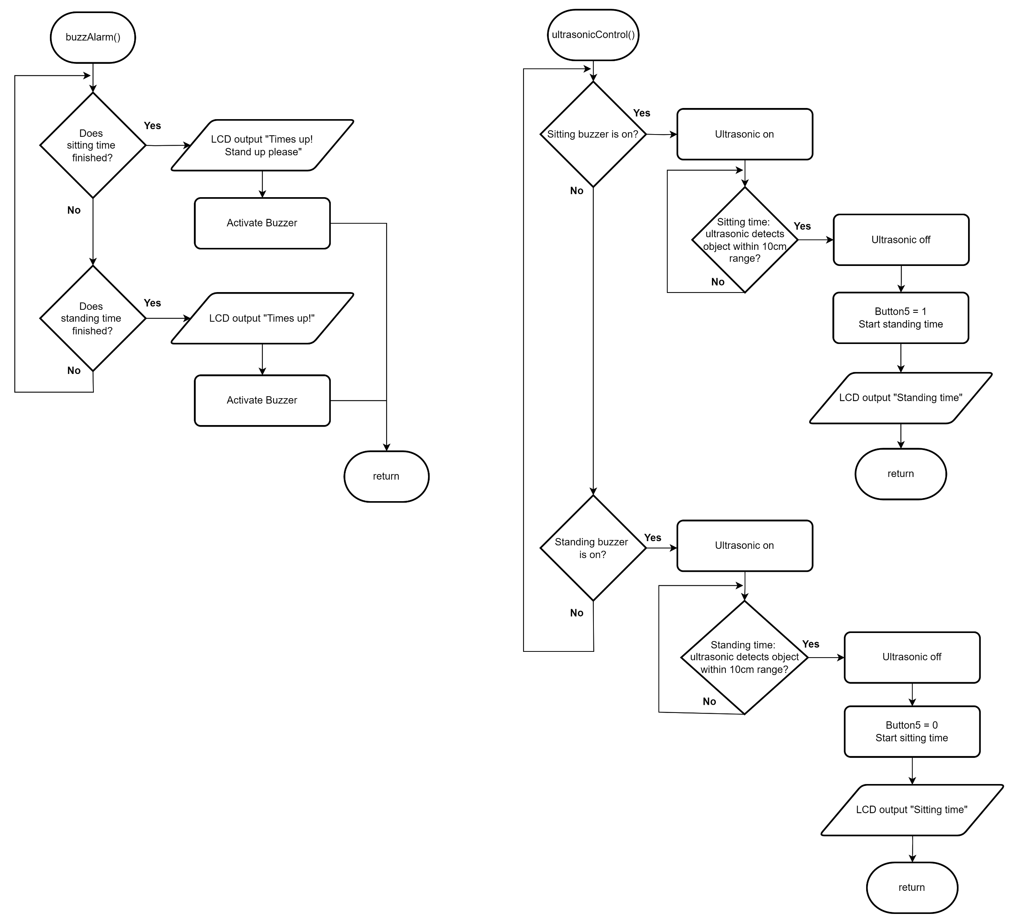

**Reference:**  
Storrs, C. (2015). *Stand up, sit less and move more, researchers say; here’s how to do it*. <https://edition.cnn.com/2015/08/06/health/how-to-move-more/index.html>